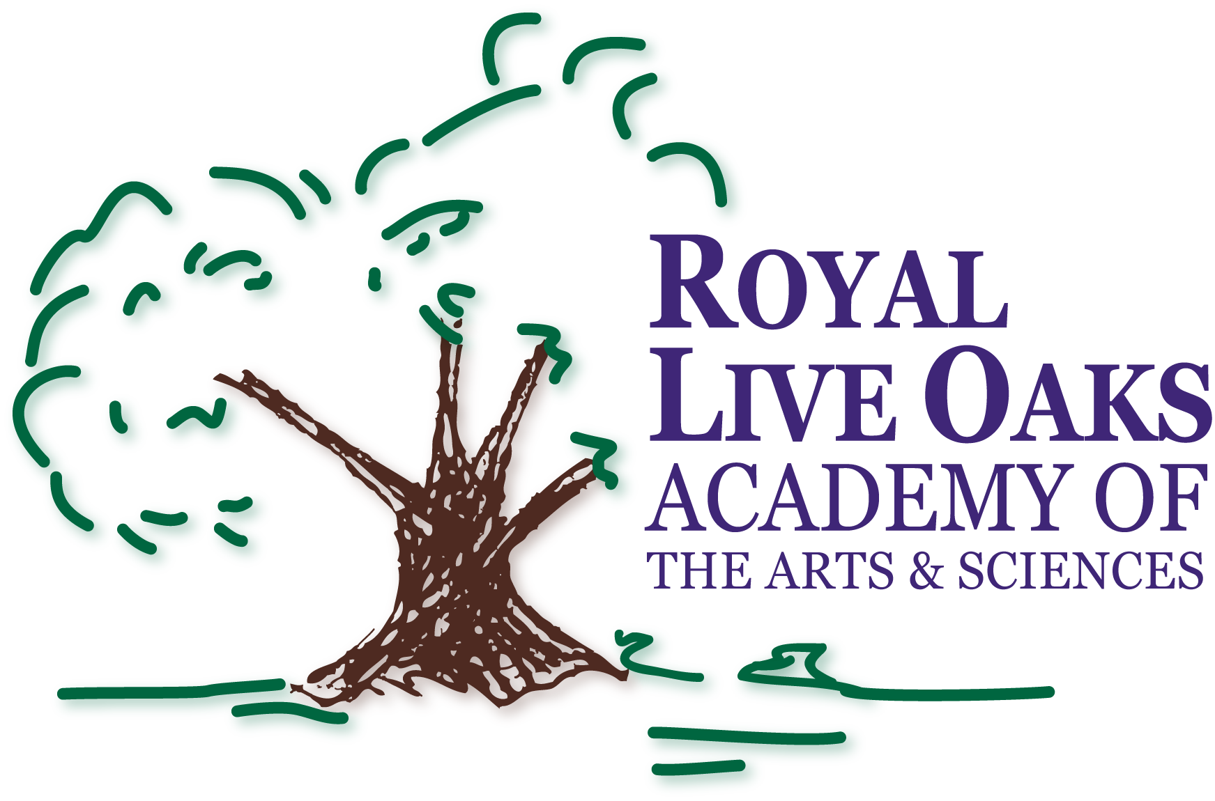1398 Church Rd., Hardeeville, SC 29927 Ph: 843-784-2630 Fax: 843-784-2623 www.the qualities of a Royal Knight.org

AGENDA
TITLE II PLAN MEETING
February 3, 2015, 5:00pm

- Call Meeting to Order – Dr. Karen Wicks
- Presentation and Explanation of Title II Plan – Dr. Karen Wicks
- Vote on Title II Plan
- Meeting Adjournment

